Git Guide
By Tymoteusz Walicnowski
- Init
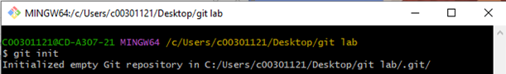
Format: git init
Creates a new git repository
- Add
Format: git add .
Adds all files (excluding ones included in .gitignore) to the next commit(?).
git add filename/pattern
Specifies which filename/pattern to add to the next commit, rather than all of them.
The add command adds files to the next commit only. If a file is modified after it is added (but not committed), it will not be updated for the commit and will need to be added again.
- Status
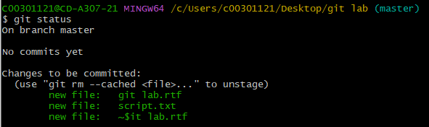
Format: git status
Lists files, modified files in working area, added files in staging area, current branch?
- Commit
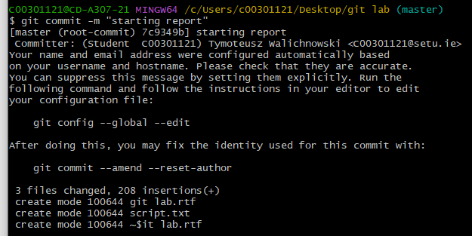
Format: git commit -m “comment”
git commit
The git command is used to create a new revision point on the local repository. A comment can be entered to detail the changes/added/removed features, this is important for letting other users know the changes made.
- Remote

- Push
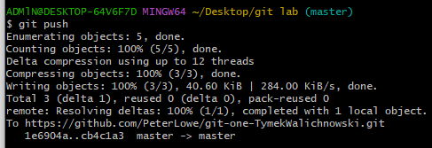
Format: git push
The git push command updates the remote node with the current node. The current node needs to be associated with the remote mode so we use ‘git push -u origin master’ to push the local master to the origin on the server. The -u means to associate with ‘my master’ with the remote master branches, and is only needed this once.

- Branch
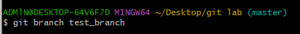
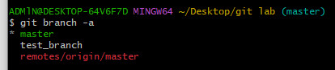
Format: git branch new_branch_name
The git branch command is used to create a new branch within the local repository. The -a/-l/-r flags can be used to list all branches located within a repository.

- Checkout
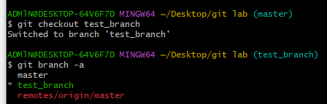
Format: git checkout branch_name
The git checkout command allows the user to make the chosen node into the current HEAD. This ensures that the working directory matches that node/commit. This command won’t work if there are modifications in the local branch that are different than the one you are switching to. The -f flag can be used to discard non committed files, but this is risky and can end with lost files.

- Merge
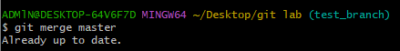
Format: git merge master
The git merge master command is used to merge the head with the master branch. Git will automatically apply changes if they are in separate elements of the project. However, it will warn of a conflict and not merge if the two merged branches have the same object but different properties under it. It is advisable to edit the relevant files first and then add them to the commit.

- Log
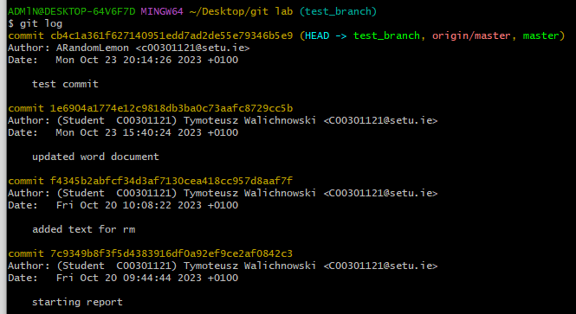
Format: git log
Git log can be used to display the entire commit history of a repository. While navigating the history, pressing the space key will bring up more, while pressing the q key will quit the navigation. The --stat flag can be added to show the files altered and what lines were changed, while the --graph flag can be used to draw the paths of branches, adding --oneline will draw the paths with a condensed output. The -n flag while only show the last amount of specified commits, input as -n.
- Clone

- Pull
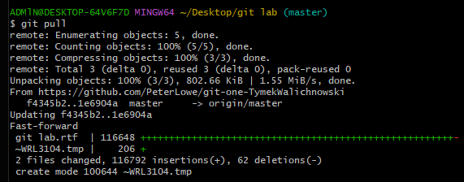

- Stash
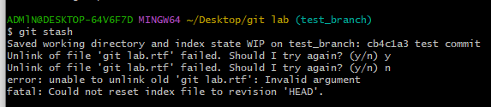
Format: git stash
The git stash command creates a local copy the current working directory for the user. The --list flag can be used to list previously pushed stashes. While the --pop flag can be used to retrieve the stash{0} and copy the files into a working directory. The git apply stash{1} command will retrieve stash{1} and copy it into the current directory.

- Rm
Format: git rm <filename>
The git rm command is used to remove files from a github repository. It is the opposite of the add command. By default it deletes file from both repository and from the file system, the --cached flag can be used so only the file in the repository is deleted. The -r flag is used to recursively remove folders. The -n flag is used if the user wishes to do a dry run, listing the files that would be deleted by the command, but not actually deleting them.

